Tree vs. chain model

There are two ways of messages forwarding related to resources negotiations, advertisements, reservations, etc. Both options has pro and cons, which are shortly described on this paper.

Daisy chain communication model
Daisy Chain communication model is based on message forwarding from one site to another in defined order, without loops or creation of nets. A message is not expected to reach the same site more than one. The chain model is depicted on Figure 1:
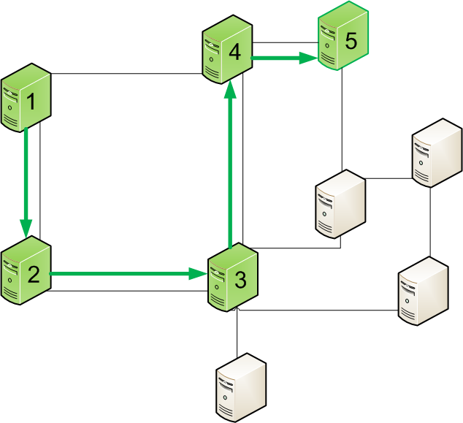
Figure 1 Chain communication model

The message from the server 1 is expected to reach server 5. Servers 2,3, and 4 may or may not be a recipient of a message (also may or may not modify it). In objects along path are not a message recipients, they need to be able to forward the message in a proper way to the next object on a routing path. A route of the message is out of scope of this paper. It can be done in OSPF like manner, BGP like manner, or any graph searching algorithm. A route can be predefined since the message sender push the message out, or can be computed at each intermediate element (next hop). The path where message can be routed depends on physical and/or logical connections between objects.

Tree communication model
Tree communication model assumes that there is no physical boundaries for reaching particular nodes. An example is depicted on Figure 2
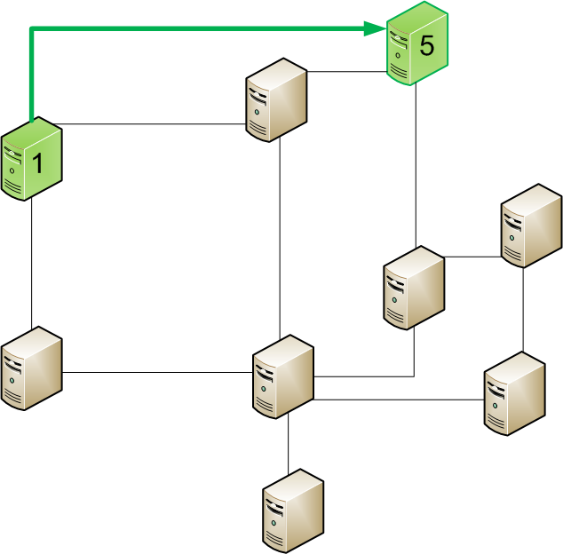
Figure 2 Tree communication model

The object 1 does not care about routing a message to the object 5 and is able to send the message directly. The message can be routed with regular IP packets routing basis, using routing tables available in the network. The message may or may not pass intermediate objects, depending on implementation. That means that message forwarding mechanism may be independent from communicating objects, and perform as a simple point-to-point connection. All nodes are independent and are expected to be reachable, despite of resources interconnectivity.

Consequences of selection of communication model
Both communication model has direct influence o capabilities and implementation of communication protocols, as they introduce some potential opportunities as well as some threads. The main difference between chain and tree model, is that chain model forces to follow step by step approach in communication.
In case of topology depicted on Figure 3 a scheduler (placed in object 1) pre-defines the path and wants to book resources in objects 1,2,3,4, and 5. There are several scenarios of performing this task.

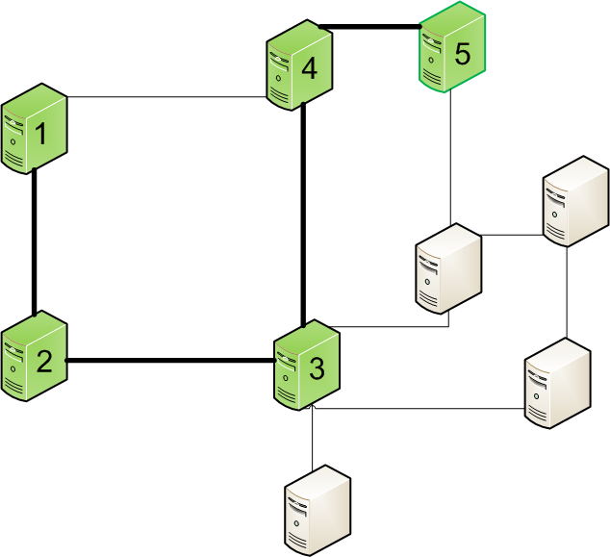
Figure 3 Resources negotiation example

Case 1: Chain model with response concatenation mechanism
A single request is forwarded from domain to domain, and responses are concatenated into one message. The response is merged at each domain on the way back to object one, as depicted on Figure 4:
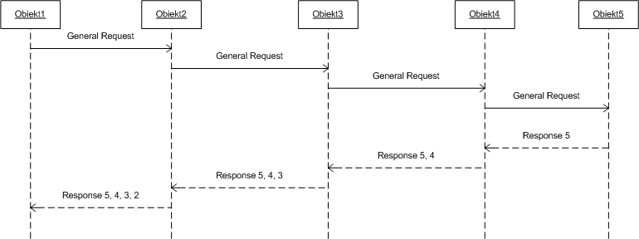
Figure 4 Chain model with response concatenation

Case 2: Chain model with “personalized” requests
Each object is receiving a separate “personalized” request and is expected to response. The messages are forwarded in chain model, and intermediate objects needs to implement mechanism to forward messages without reading it (communication layer). The communication schema for this case is depicted on Figure 5:
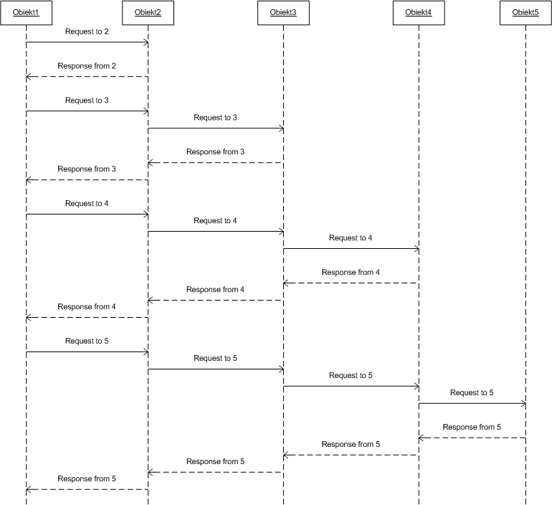
Figure 5 Chain model with "personalized" requests

Case 3: Chain model with generic request and “personalized” responses
The request is forwarded in object-to-object manner, while each domain is responsible to create an independent “personalized” response and send it back to the object 1. Intermediate objects needs to implement mechanism to forward messages without reading it (communication layer). The communication schema for this case is depicted on Figure 6:
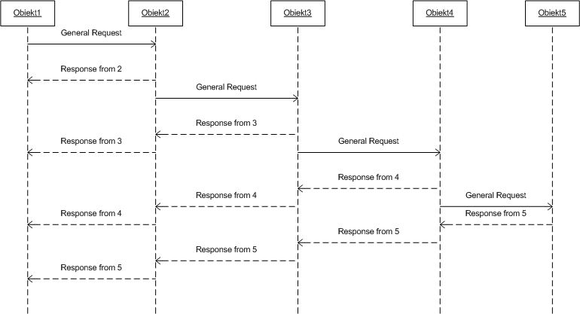
Figure 6 Chain model with generic request and "personalized" responses

Case 4: Tree model
Each object receives a “personalized” request directly from the object 1, and sends “personalized” response directly to the object 1. The communication schema is depicted on Figure 7:
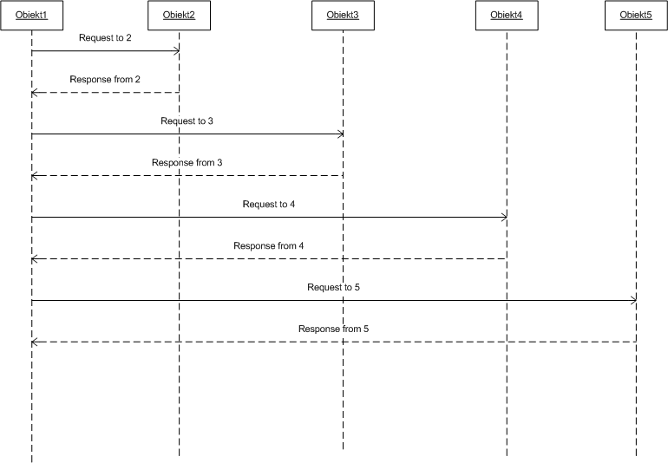
Figure 7 Tree model

The main advantages and disadvantages of chain and tree model can be easily observer in case of failures and critical situations. As tree model does not care for physical/logical connectivity between objects, the message is just sent to the destination object. Success or failure of message delivery depends on the algorithms of message routing or simply IP network layer. In case of chain model, failure of single object may disturb reachability of other objects behind.

